**SCDL App:**

*Main Menu Items*

**Admission**

**Important Dates**

**Programs**

**Student Support Services**

**Academics & Assessments**

**About Symbiosis**

**Student Testimonials**

**Contact US**

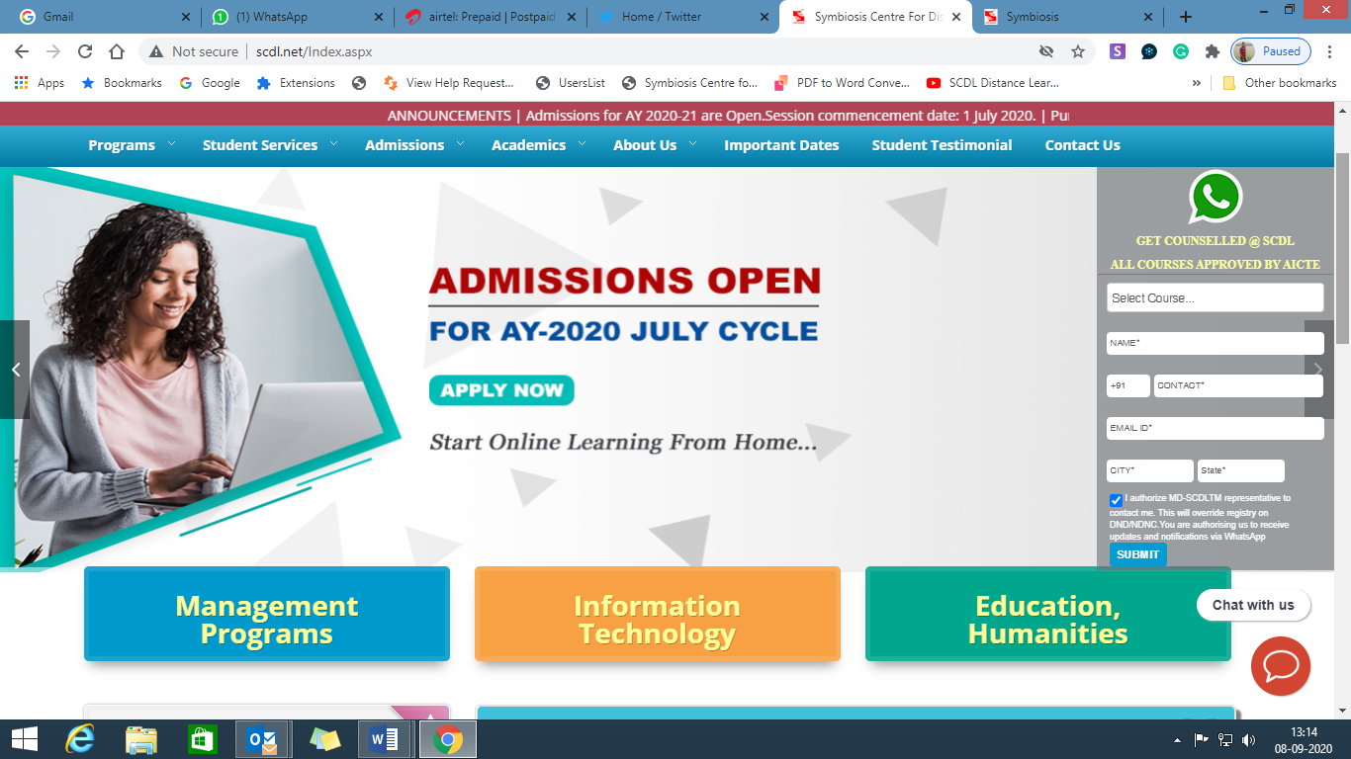WhatsApp Icon to be placed on Home page with Student Data Captured form.

Apply Online Icon to be placed on Home Page of the App

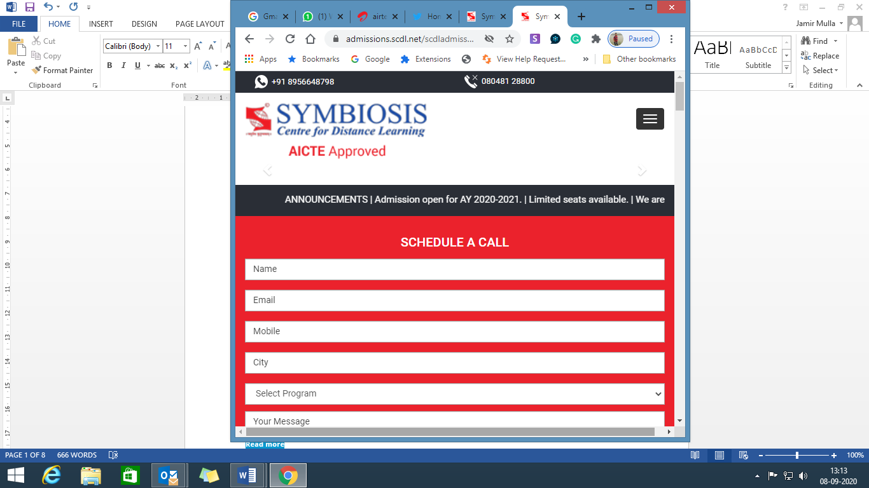

**Page 1 Admission:**

[**How to Apply**](http://www.scdl.net/how-to-apply-online.aspx)

[**Read more**](http://www.scdl.net/how-to-apply-online.aspx)

[**Admission Status Search**](http://www.scdl.net/AdmissionStatus.aspx)

[**Read more**](http://www.scdl.net/AdmissionStatus.aspx)

[**Frequently Asked Questions**](http://www.scdl.net/frequently-asked-questions.aspx)

[**Read more**](http://www.scdl.net/frequently-asked-questions.aspx)

[**AICTE Approval Letter (AY 2020-21)**](http://www.scdl.net/pdf/SCDL%20EOA%202020-21.pdf)

[**Read more**](http://www.scdl.net/pdf/SCDL%20EOA%202020-21.pdf)

[**Student Testimonials**](http://www.scdl.net/student-testimonials.aspx)

[**Read more**](http://www.scdl.net/student-testimonials.aspx)

[**Refer a Friend**](http://www.scdl.net/refer-a-friend.aspx)

[**Read more**](http://www.scdl.net/refer-a-friend.aspx)

[**Induction Program and Webinars**](http://www.scdl.net/InductionProgram.aspx)

[**Read more**](http://www.scdl.net/InductionProgram.aspx)

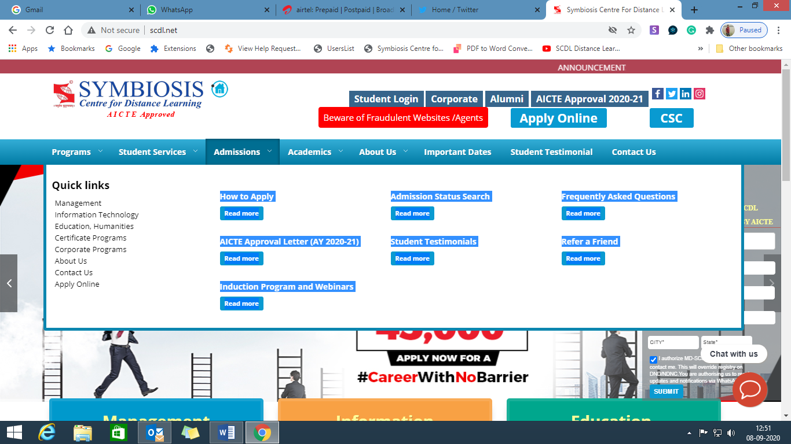

**Page 2 Important Dates:**

<http://www.scdl.net/ImportantDates.aspx>

Important Dates for Admission for AY 2020-21

AY 2020-21, Cycle 1 – July Batch

Round 1

**21st April 2020**  
Admissions Open

**Important dates Cycle 1 – July Batch :**

1. Program commenced: **1st July 2020.**
2. Online Classes commenced from: **2nd July 2020.**.
3. Last date for change in specialisation: **31st July 2020**.
4. Last date for change in program: **31st July 2020**.
5. Last date to submit deficient document/s to SCDL: **10th August 2020.**
6. Last date to apply for dual specialisation: **31st August 2020.**
7. Admission cancellation - refund of fee: **20th August 2020.**
8. Pay Full Program Fee as per one of the below options, whichever is earlier, on or before **10th August 2020:**
   * Option 1: One Instalment: Pay 1st Instalment within 30 days of grant of confirmed admission.
   * Option 2: Two Instalments: Pay 1st Instalment within 15 days of grant of confirmed admission. Pay 2nd Instalment within 60 days of payment of 1st Instalment payment or on or before the last date to pay full fee, whichever is earlier or as informed by SCDL.
9. Assignment Releases by: **Aug – Sept. 2020**
10. Exams Releases by: **Sept. – Oct 2020**.

**Page 3 – Programs**

**Quick links – Drop Down or POP UP will open**

* [Management](http://www.scdl.net/Management.aspx)
* [Information Technology](http://www.scdl.net/InformationTechnology.aspx)
* [Education, Humanities](http://www.scdl.net/EducationHumanities.aspx)
* [Certificate Programs](http://www.scdl.net/CertificateProgramNews.aspx)
* [Corporate Programs](http://corporate.scdl.net/CorporateHome.aspx)
* [Design](http://www.scdl.net/DesignPrograms.aspx)
* [About Us](http://www.scdl.net/about-symbiosis-center-for-distance-learning.aspx)
* [Contact Us](http://www.scdl.net/contact-us.aspx)
* [Apply Online](http://www.scdl.net/applyonline)

[**MANAGEMENT**](http://www.scdl.net/Management.aspx)

[**Post Graduate Diploma in  
Business Administration**](http://www.scdl.net/distance-learning-universities-in-business-administration-finance-marketing-HR-operations-CRM.aspx)

(Splz.: Marketing/Finance/Operations/  
HR/CRM/Management Accounting)

[**Post Graduate Diploma in:**](http://www.scdl.net/ManagementPostGraduateDiploma.aspx)

* [International Business](http://www.scdl.net/online-distance-learning-college-in-international-business.aspx)
* [Banking and Financial Services](http://www.scdl.net/distance-learning-education-in-banking-finance.aspx)
* [Human Resource Mgmt.](http://www.scdl.net/online-distance-learning-in-human-resource-management.aspx)
* [Insurance Business Mgmt](http://www.scdl.net/distance-learning-center-in-insurance-management.aspx)
* [Retail Mgmt](http://www.scdl.net/distance-learning-course-in-retail-management.aspx)
* [Customer Relationship Mgmt](http://www.scdl.net/online-education-programmes-in-customer-relationship-management.aspx)
* [Supply Chain Mgmt](http://www.scdl.net/distance-learning-institute-in-supply-chain-management.aspx)
* [Export and Import Mgmt](http://www.scdl.net/distance-learning-program-in-export-import-management.aspx)
* [Business and Corporate Laws](http://www.scdl.net/distance-learning-in-business-corporate-law.aspx)
* [Personnel & HRM [LL]](http://www.scdl.net/post-graduate-diploma-in-labour-laws-and-employee-relations.aspx)
* [Project Mgmt](http://www.scdl.net/distance-learning-program-in-Project-Management.aspx)
* [Energy Mgmt.[Renewable Energy]](http://www.scdl.net/distance-learning-in-renewable-energy-management.aspx)

[**Post Graduate Certificate in Management:**](http://www.scdl.net/ManagementPostGraduateCertificate.aspx)

* [Entrepreneurship Development](http://www.scdl.net/distance-learning-in-entrepreneurship-development.aspx)
* [Event Management](http://www.scdl.net/distance-learning-pg-diploma-in-mediaand-event-mgt.aspx)
* [Cyber Laws](http://www.scdl.net/distance-learning-in-cyber-laws.aspx)

[**Post Graduate Certificate in Finance:**](http://www.scdl.net/PostGradateCertificateinFinance.aspx)

* [Taxation Laws](http://www.scdl.net/distance-learning-diploma-in-taxation-laws.aspx)
* [Management Accounting](http://www.scdl.net/distance-learning-in-management-accounting.aspx)

[**Certificate Programs in:**](http://www.scdl.net/CertificateProgramNews.aspx)

* [Building an Online Business](http://www.scdl.net/certificate-course-in-building-an-online-business.aspx)
* [Disaster Management](http://www.scdl.net/certificate-course-in-disaster-management.aspx)
* [IPR and Patent Law](http://www.scdl.net/certificate-course-in-IPR-and-patent-law.aspx)
* [Virtual Workplace Mgmt.](http://www.scdl.net/certificate-course-in-virtual-workplace-management.aspx)
* [Single Courses](http://www.scdl.net/single-courses.aspx)

[**DESIGN**](http://www.scdl.net/EducationHumanities.aspx)

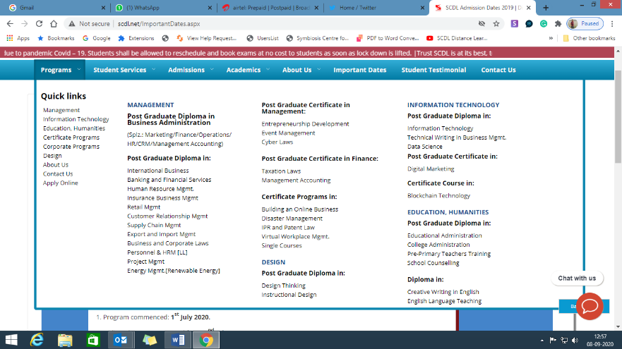[**Post Graduate Diploma in:**](http://www.scdl.net/EducationPostGraduateDiplomaIn.aspx)

* [Design Thinking](http://www.scdl.net/distance-learning-diploma-in-design-Thinking.aspx)
* [Instructional Design](http://www.scdl.net/distance-learning-in-instructional-design.aspx)

[**INFORMATION TECHNOLOGY**](http://www.scdl.net/InformationTechnology.aspx)

[**Post Graduate Diploma in:**](http://www.scdl.net/ITManagmentPostGraduateDiplomaProgram.aspx)

* [Information Technology](http://www.scdl.net/distance-learning-in-information-technology.aspx)
* [Technical Writing in Business Mgmt.](http://www.scdl.net/online-learning-courses-in-technical-writing.aspx)
* [Data Science](http://www.scdl.net/distance-learning-program-in-data-science-and-statistics.aspx)

[**Post Graduate Certificate in:**](http://www.scdl.net/ITManagementPostGraduateCertificateProgram.aspx)

* [Digital Marketing](http://www.scdl.net/distance-learning-in-digital-marketing.aspx)

[**Certificate Course in:**](http://www.scdl.net/ITManagementCertificatePrograms.aspx)

* [Blockchain Technology](http://www.scdl.net/certificate-course-in-blockchain-technology.aspx)

[**EDUCATION, HUMANITIES**](http://www.scdl.net/EducationHumanities.aspx)

[**Post Graduate Diploma in:**](http://www.scdl.net/EducationPostGraduateDiplomaIn.aspx)

* [Educational Administration](http://www.scdl.net/distance-learning-program-in-educational-administration.aspx)
* [College Administration](http://www.scdl.net/distance-learning-diploma-in-College-Administration.aspx)
* [Pre-Primary Teachers Training](http://www.scdl.net/distance-learning-in-pre-primary-teachers-training.aspx)
* [School Counselling](http://www.scdl.net/distance-learning-in-school-Counselling.aspx)

[**Diploma in:**](http://www.scdl.net/EducationDiplomaProgram.aspx)

* [Creative Writing in English](http://www.scdl.net/distance-learning-diploma-in-creative-writing-in-english.aspx)
* [English Language Teaching](http://www.scdl.net/distance-learning-diploma-in-teaching-english.aspx)

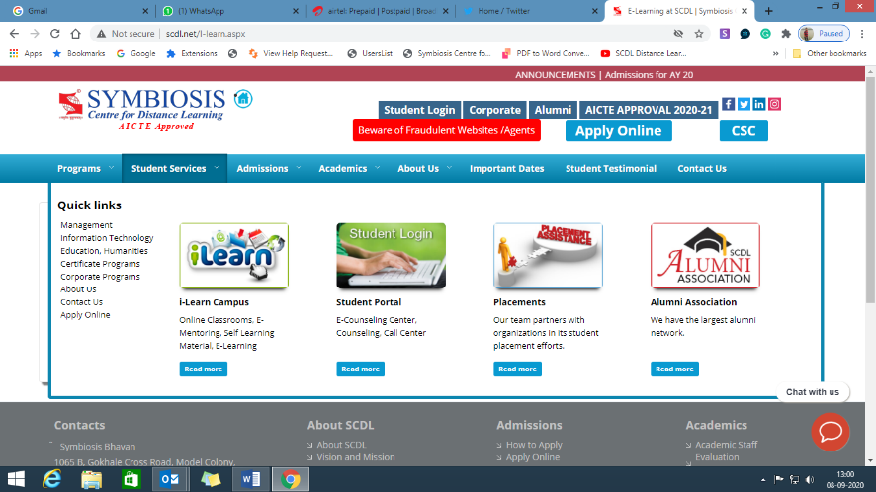**Page – 4 Student Support Services**

**I-Learn Campus**

**Student Seva**

**Placements**

**Alumni Association**

Student Centric Learning Approach – Infographics

**Page 5- Academics – Assessments**

**Online Classrooms**

Students are able to attend a live online classroom and interact with expert faculty via the internet

**E-Mentoring**

Students can interact with our tutors via online chat sessions.

**Self Learning Material**

Comprehensive Self learning material is specially prepared for every course by our in-house Academics Department, with the distance learning methodology in mind

**E-Learning**

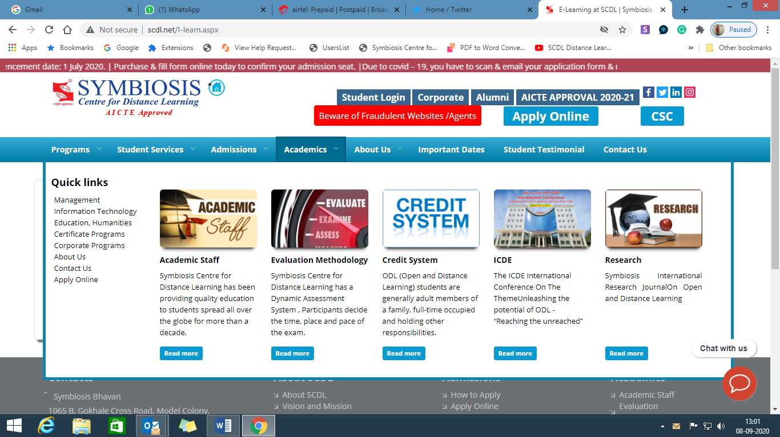Interactive E-Learning comprising of case studies and scenarios are developed in-house and act as a supplementary learning mode

**Page 6- About Symbiosis**

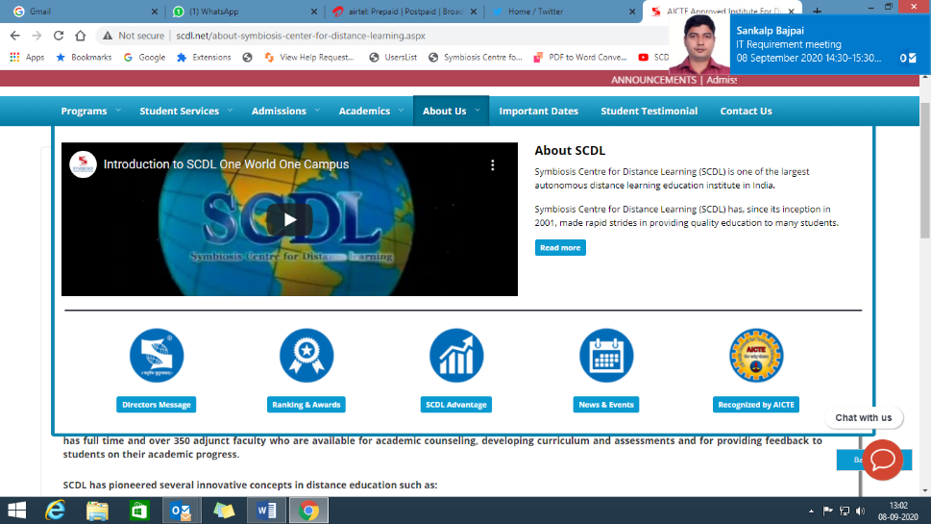**About SCDL**

**Vision and Mission**

**Presidents Message**

**Directors Message**

**Rankings and Awards**

**Symbiosis Group**

**SCDL Advantage**

**Recognition**

**Page -7 Student Testimonials**

We will send the details separately in word file with good pictures of the students

**Page 8 News and Events**

Events

Newsletter

Media Coverage

**Page -8 Contact US**

Contact Us

Contacts

Symbiosis Bhavan

1065 B, Gokhale Cross Road, Model Colony,

Pune - 411016, Maharashtra, India.

Telephone: +91-20-66211000 / 9370722198

Fax: +91-20-66211040/66211041

WhatsApp : 8956648798

Existing students can write to us through Post My Query from their student login.

Fresh Admission queries: newadmissions@scdl.net

SCDL Working Hours: 9:30 AM to 5:30 PM

Connect with us...

Student Feedback Form *(Hyper link to Feedback Form)*

